PROJECT ARCHITECTURE

MVC PATTERN

Field | Details
Date | 26 June 2026
Team Id
Project Name | House Rent
Maximum Marks | 4 Marks

MVC Pattern
The HOUSE RENT application follows the Model–View–Controller (MVC) architectural pattern, which separates the application into three independent layers: Model, View, and Controller. This architecture improves maintainability, scalability, code organization, and collaboration among developers.

Model Layer (Data Layer)
The Model layer is responsible for handling all application data and database operations.
Responsibilities
- Defines MongoDB schemas using Mongoose.
- Performs Create, Read, Update, and Delete (CRUD) operations.
- Stores user, property, booking, and booking history information.
- Validates and manages application data.

Controller Layer
The Controller acts as the communication bridge between the View and the Model.
Responsibilities
- Receives HTTP requests from users.
- Validates incoming data.
- Executes business logic.
- Calls Model functions.
- Returns appropriate responses to the client.

View Layer (Routing Layer)
In a MERN-based REST API, the View is represented by the routing layer.
Responsibilities
- Defines REST API endpoints.
- Receives HTTP requests (GET, POST, PUT, DELETE).
- Invokes the appropriate controller methods.
- Sends responses back to the frontend.

Advantages of Using MVC
- Separation of Concerns: Each layer has a specific responsibility, making the project easier to maintain.
- Scalability: New modules and features can be added without affecting existing components.
- Reusability: Controllers and Models can be reused across multiple routes.
- Testing: Each layer can be tested independently.
- Collaboration: Frontend and backend developers can work simultaneously with minimal conflicts.

Workflow
- User sends a request through the frontend.
- The request reaches the appropriate route (View Layer).
- The Controller processes the request.
- The Controller interacts with the Model.
- The Model communicates with MongoDB.
- The response is returned through the Controller to the frontend.
- The user receives the requested information.

Example – MVC Architecture Diagram:
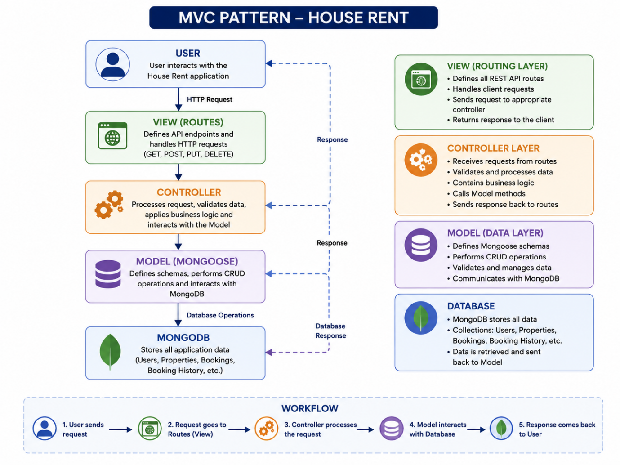

Figure 1: Model–View–Controller (MVC) Architecture of the HOUSE RENT Application.

Reference:
- https://developer.mozilla.org/en-US/docs/Glossary/MVC
- https://mongoosejs.com/
- https://expressjs.com/

